**PART 1 - READING ASSIGNMENT**[https://learning.oreilly.com/library/view/mongodb-in-action/9781617291609/?ar (Links to an external site.)](https://learning.oreilly.com/library/view/mongodb-in-action/9781617291609/?ar)

  Chapter 4. Document-oriented data

  Chapter 5. Constructing queries

  Chapter 6. Aggregation

Note: If you cannot access the chapters, enter your neu email as @northeastern.edu instead of @husky.neu.edu

**PART 2 - PROGRAMMING ASSIGNMENT**

 Write a .bat/.sh to import the entire NYSE dataset (stocks A to Z) into MongoDB.

 NYSE Dataset Link: http://msis.neu.edu/nyse/

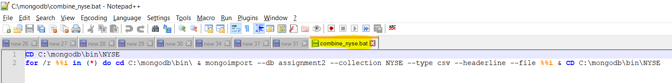

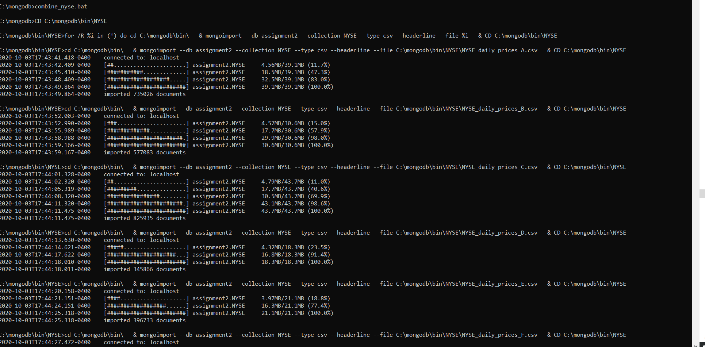

**PART 3 - PROGRAMMING ASSIGNMENT**

PART 3.1. Use the NYSE database to find the average price of stock_price_high values for each stock using MapReduce.

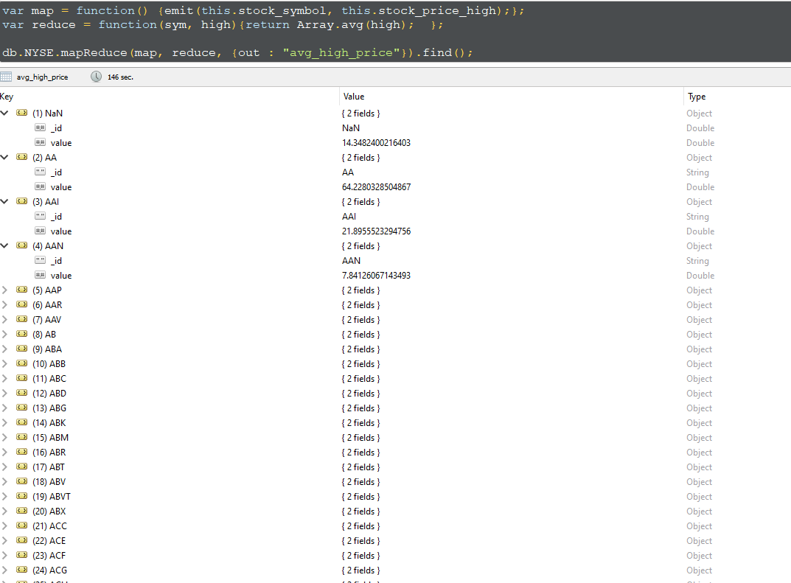

PART 3.2. Part 3.1 result will not be correct as AVERAGE is a commutative operation but nor associative. Use a FINALIZER to find the correct average. (Hint: pass sum and count from the reducer) (https://docs.mongodb.com/manual/reference/method/db.collection.mapReduce/index.html)

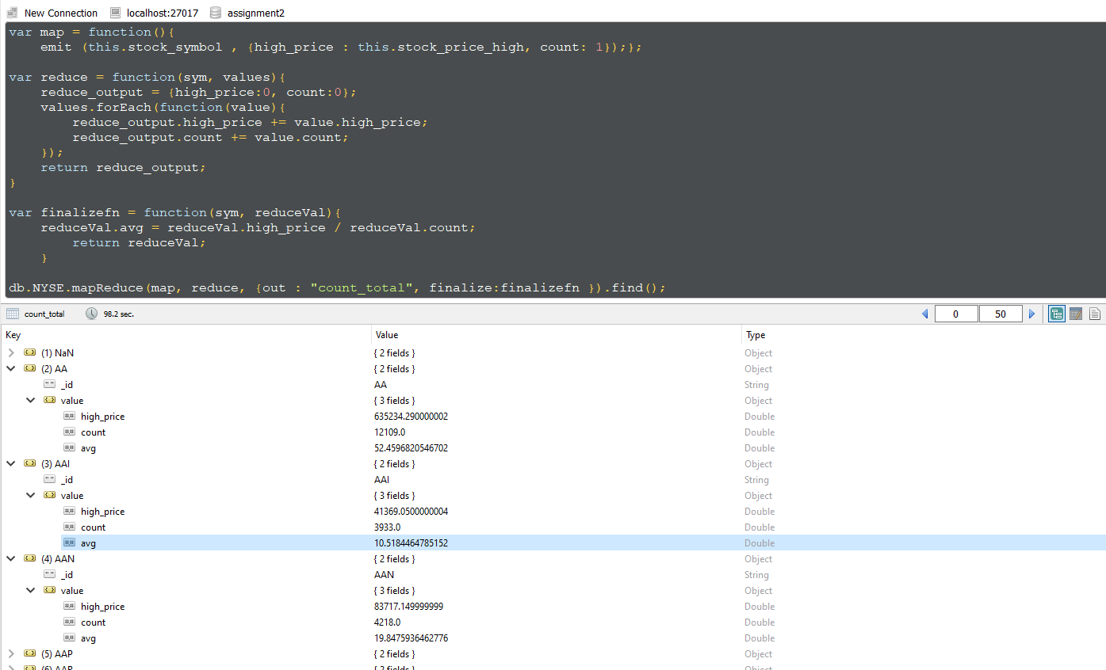

**PART 4 - PROGRAMMING ASSIGNMENT**

PART 4. Calculate the average stock price of each price of all stocks using $avg aggregation.

[https://docs.mongodb.com/manual/reference/operator/aggregation/avg/ (Links to an external site.)](https://docs.mongodb.com/manual/reference/operator/aggregation/avg/)

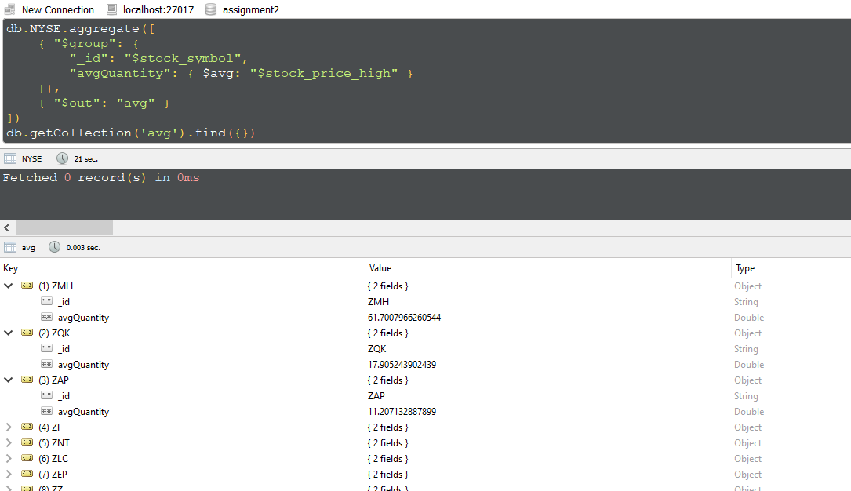

**PART 5 - PROGRAMMING ASSIGNMENT**

Import the Movielens dataset into MongoDB. Refer to README about file contents and headings.

[https://grouplens.org/datasets/movielens/1m/ (Links to an external site.)](https://grouplens.org/datasets/movielens/1m/)   [you may replace :: in the dateset with comma or tab to import]

* Find the number Females and Males from the users collection using MapReduce. Do the same thing using count() to compare the results.

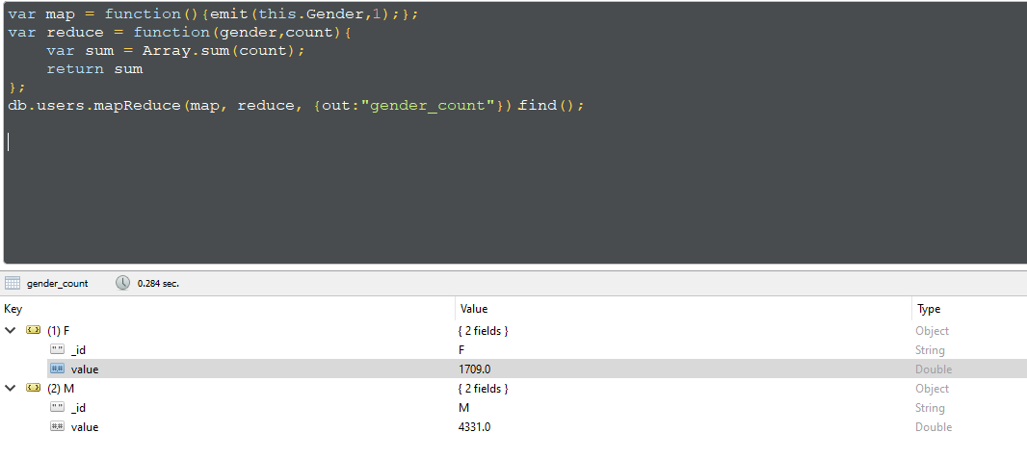

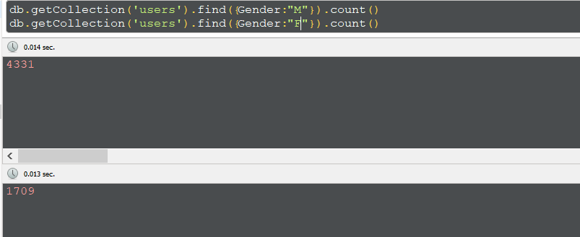

* Find the number of Movies per year using MapReduce

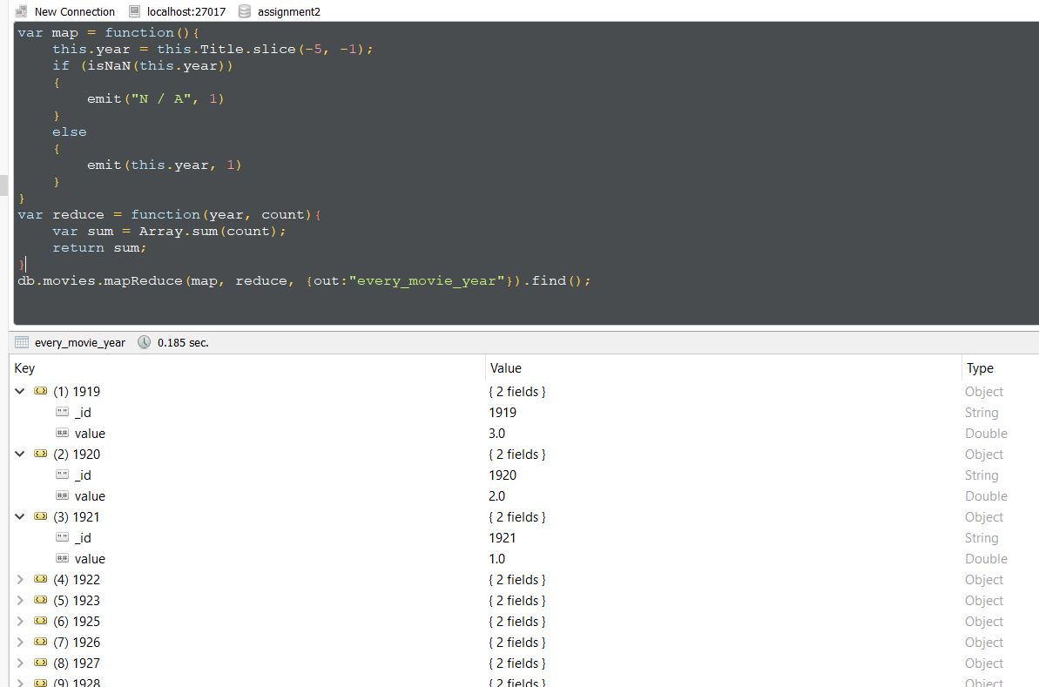

* Find the number of Movies per rating using MapReduce

